# Fighting COVID-19 Android App

##### **Keval B. Shah, Dhruv D. Harsora, Vivek K. Thummar, Vivek T. Valand**

1. Introduction

Android Development technology had been applied in various applications such as Online Shopping, Social Media and many more. This paper describes the implementation of an Android Application used for “Fighting with COVID-19”. This application is totally divided into two phases, the first phase is for the guest user. Where the guest will have to fill up the form on the android application with the true information and then further, they can check the Probability of having Coronavirus and further then can contact to their family doctor. In the second phase the user need register for the first time and he/she is already registered then they need to login for the further access and once they are logged-in in the application they will get the three choices to do, first choice is that they fill up the form and in this form they also have to add there Family doctor name and Mobile number and then they will able to see the Corona Test result and if they think that the result is very dangerous then they can send the SMS to their enter doctor name and number. Second choice the user get is that then view the live Corona Cases of India which contain the details of Total Cases, Active Cases, Death Cases and Recovered Cases and the final choice the user get is that they can view their profile.

1. Hardware & Software Requirements

* Android Studio:
* Open-source software
* Android Studio is the official integrated development environment (IDE) for Google's Android operating system, built on JetBrains' IntelliJ IDEA software and designed specifically for Android development.
* It is available for download on Windows, macOS and Linux based operating systems.
* It is a replacement for the Eclipse Android Development Tools (ADT) as the primary IDE for native Android application development.

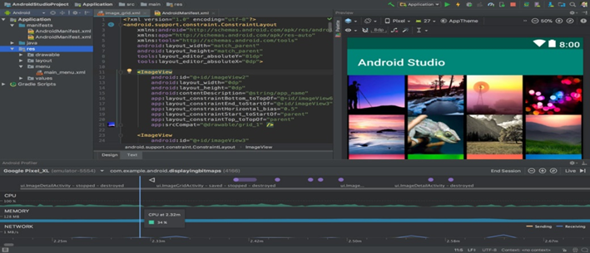

1. Process Flow

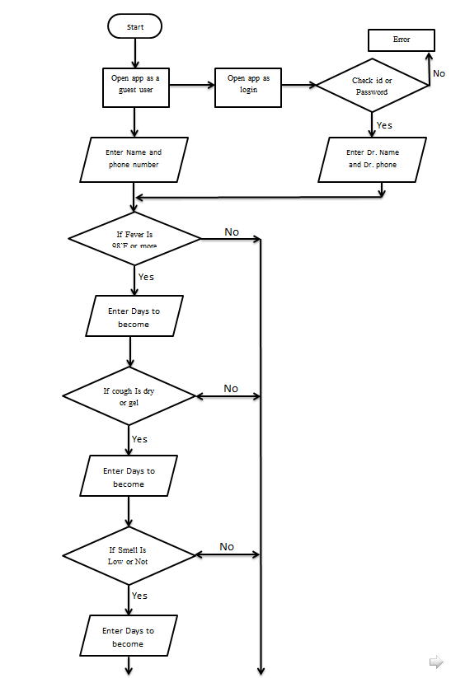

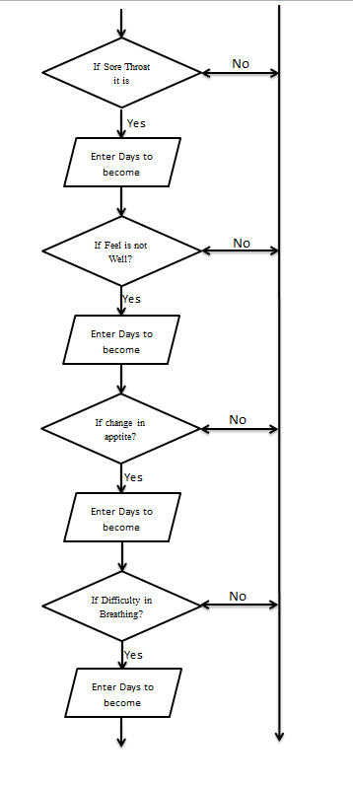

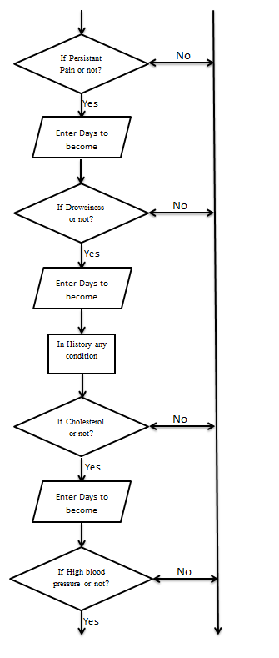

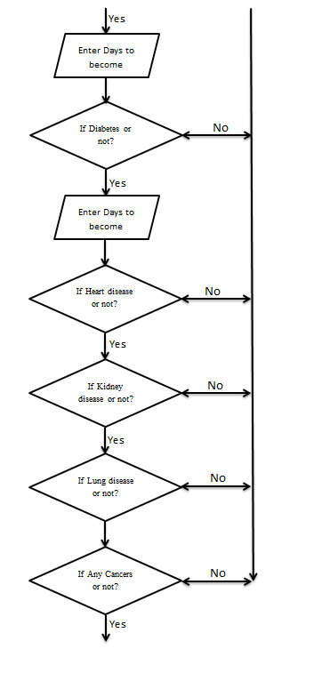

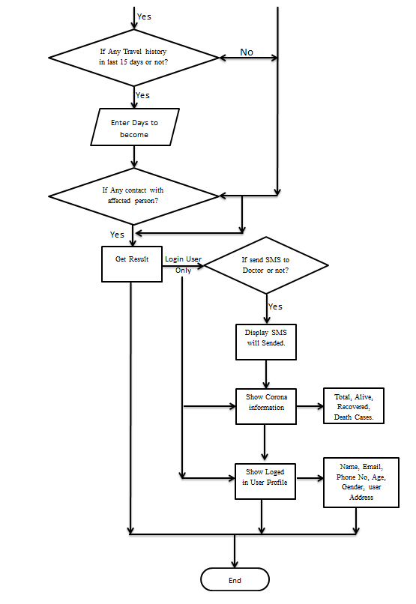

1. Data Flow Diagram

* There are Six Data flow diagram by application working principal.

